Advanced
Child Protection Training Workbook
SEPT 2026
*Please download a digital copy for use during training* ACP
The document content is protected but you can type notes where prompted, or print a copy if you prefer




Contents
Please be aware that some of the course resources and content contain sensitive content, that you may find upsetting. This training aims to educate and raise awareness, based on learning from case reviews and research, but it can evoke emotional responses, particularly for individuals with personal connections to child or adult bereavements, or the incidents themselves.
We encourage you to prioritise your well-being. Take breaks, reflect on your boundaries, and seek support from trusted individuals or professionals as needed.
For assistance during or after the training, please reach out to the trainer or your line manager in the first instance. South Gloucestershire Council Staff may also contact Interchange the staff counselling service or can also access Thrive.
We are committed to creating an inclusive learning environment and promoting empathy and respect for all. If you have any requests or questions please contact HRlearninganddevelopment@southglos.gov.uk
Item Page
Pre-Course Resources
- Distance Learning 3
- Learning Log 4

Course Activity Resources
- Refresher Quiz – Local Knowledge 5
- Effective Multi-Agency Work ? 6
- Responses to Levels of Need Exercise 7 & 8
- Assessment Exercise 9
- What Good Looks Like – Referral Exercise 10-11
- Acronym’s, Initialisations & Reflection Exercise 12
- Your Notes 13

Post Course Resources
- Access other course resources here ACP
- For all South Glos Children’s Partnership Resources visit SGCP Website
- Please share your feedback? - QR Code or link Online Evaluation Form
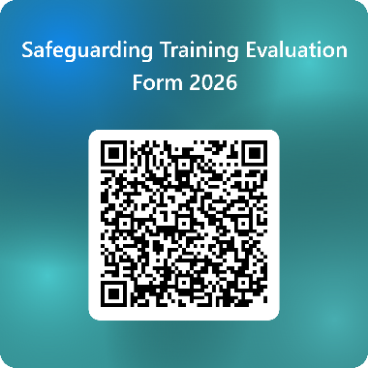

Distance Learning
There are ten course objectives and to achieve this learning we will complete group discussions and exercises throughout the day. Your engagement and participation is the key to success. We all learn from each other through discussion and sharing of knowledge and experiences.
One important objective is ‘to develop confidence in professional judgement and the application of local thresholds and procedures’.
In order the get the most from our Multi-Agency training opportunity, before you attend, please take some time to familiarise yourself with the most current local guidance for professionals and learning from local Child Safeguarding Practice Reviews.
*Ctrl+Click on the below image to access the document.
BNSSG Regional Threshold and Support Framework for Children and Families.
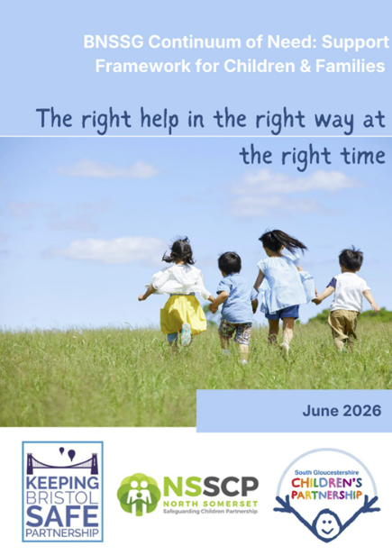

Local Learning from Case Reviews
*Ctrl+Click on the below link to access the material.
Child Safeguarding Practice Reviews (CSPR)

It is possible to view this material online or download a digital copy. There is no requirement to print this material for the training session, unless you wish to do so.
Also, prior to starting the course, take a look at the learning log on page 4, and answer question 1).
Learning Log

My Learning Aim / Objective

Prior to starting the course, please write here one thing you hope to have learned / developed by the end of the training:

My Key Learning Points

During the session write here the most important things you have learned during the session

My Key Action Points

After the training reflect and include here the key things you will do as a result of attending this training e.g. further reading or acting on concerns about a particular child. I will review my progress on these actions by Date? _________

Review and Reflect

On the date you set at 3) review your key action points and record your progress/activity here.

Refresher Quiz – Local Knowledge
- Name the strategic body that ensures children are safeguarded and protected in South Gloucestershire.

- Which pieces of Legislation govern child safeguarding and protection?

- What do you know about the following sections of The Children Act 1989?

- S17
- S47
- S20

- Add the dates of the most current versions of Statutory/Non Statutory Guidance:
a) Working Together to Safeguard Children (YYYY)
b) Keeping Children Safe in Education (YYYY)
c) Early Years Foundation Stage (Settings) (YYYY)
d) Early Years Foundation Stage (Childminders) (YYYY)
e) Domestic Abuse Statutory Guidance (YYYY)
f) After School Clubs, Community Activities and Tuition (YYYY)

- Name the 4 tiers of help and support set out in the BNSSG Regional Threshold and Support Framework for Children and Families. ‘Right Help, in the Right Way at the Right Time’.

- What is the name of the South Gloucestershire Children’s Partnership team that supports and is known as the ‘Engine room’ of local Early Help provision?

- Describe the function of The Access & Response Team (ART)

- What does the acronym MASH stand for?

- What does the acronym LADO stand for?

- When can you share information with other agencies about a child or a family without their consent?

- What is the name of the South Gloucestershire Children’s Partnership policy that professionals can use in the event of decisions or progress disagreements.

- Make a list of local Child Safeguarding Practice Reviews published since 2021?
Effective Multi-Agency Working
All practitioners working as part of Multi-Agency approaches play a crucial role in Safeguarding and Child Protection.

In your team discuss and make a list of key practice points that help to support effective multi-agency working and information sharing. Take a look at this great reflective resource to further develop your knowledge and confidence. NSPCC - Practice Points Series

Responses to Levels of Need Exercise
Discuss the following four examples with your group and decide what needs to happen next. (consider the most appropriate response, support, safeguards and how you might work with the family)
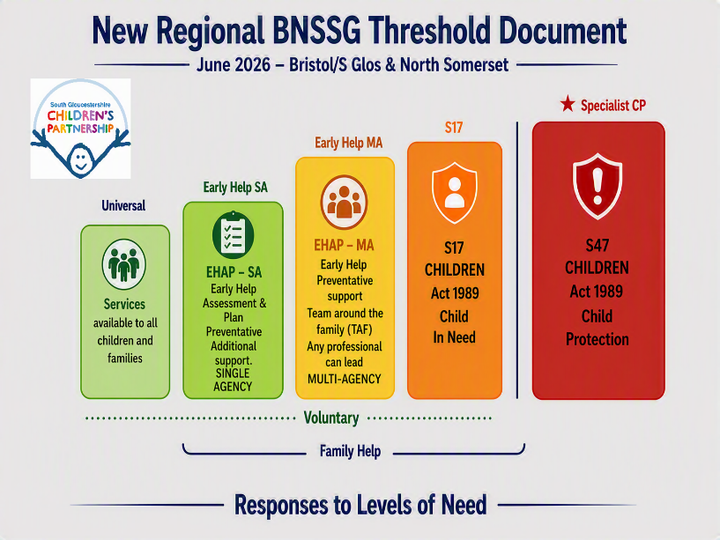
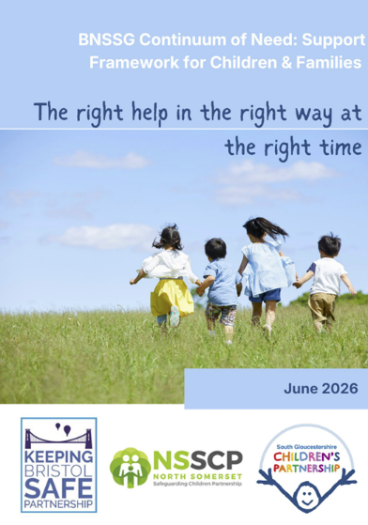
Click image to access document

Example 1
Mum is struggling with B’s behaviour at home. Mum finds they are particularly difficult when needing to get ready for school or for bedtime. The child is negative about going to school. Mum would like to receive some support and to learn how to manage their behaviour.

Notes
Example 2
A parent is worried that their 2 year old child has an undiagnosed learning need. They describe how the toddler has become quiet and subdued at home and now gets upset and cries when being taken to child care. The family has recently gone through a difficult divorce and domestic abuse has been a factor.

Notes
Example 3
S is 14, Parents have noticed a recent change in their behaviour and are worried. S has been truanting from school. They have stopped spending time with their usual friendship group. Parents do not know their new friends as S will not tell them. S is spending lots of time on their phone and hides it when parents come near. Parents are arguing a lot in the home. S has started staying out later and later and is not coming home at times set by parents. They have been wearing clothes that look new that are not recognised by parents. On Saturday S did not return home until midnight, parents had no idea where they had been. S seemed ‘jittery’ and would not speak or make eye-contact, S ran straight to their room and will not speak to parents.

Notes
Example 4
J is 9 years old and has reported that Mum has hurt them. They have been asked what this means but says that they are not allowed to say anything. An injury has been seen, reported to look like finger marks to their right upper arm, noticed when they had taken their jumper off. When asked about this J became instantly upset, and cried uncontrollably. Mum has recently had a new baby and often presents as low in mood. Mum has previously talked about finding things really hard in managing J’s behaviour at home. J has said their Dad is not with Mum anymore and the baby has a different Dad. There are no other details known for either Father.

Notes


Assessment Exercise
You will now watch a video featuring Sam who will share their current situation with you. Sam is struggling with being a single parent, mental health issues and alcohol. *The video contains strong language and references to child abuse, sexual abuse and sexual violence*
Make notes for your allocated group task ready for a whole class discussion.
Group 1 | Group 2
Key Safeguarding Themes ? (Key Themes & Vulnerability) | What is going well?  (Safety & Strength)
Group 3 | Group 4
What are you worried about?  (Who & Why?) | What will you do next?  (Actions & Why?)

What Good Looks Like - Referral Exercise
Consider what a ‘good’ referral to children’s services might look like.
What should you include and what to avoid?
Take a look at the South Gloucestershire Request for help form to get you started South Gloucestershire Council Request for Help Form (Updated July 2026) The infographic on the next page will also help.
Be prepared to share your idea’s in a class discussion.
Notes

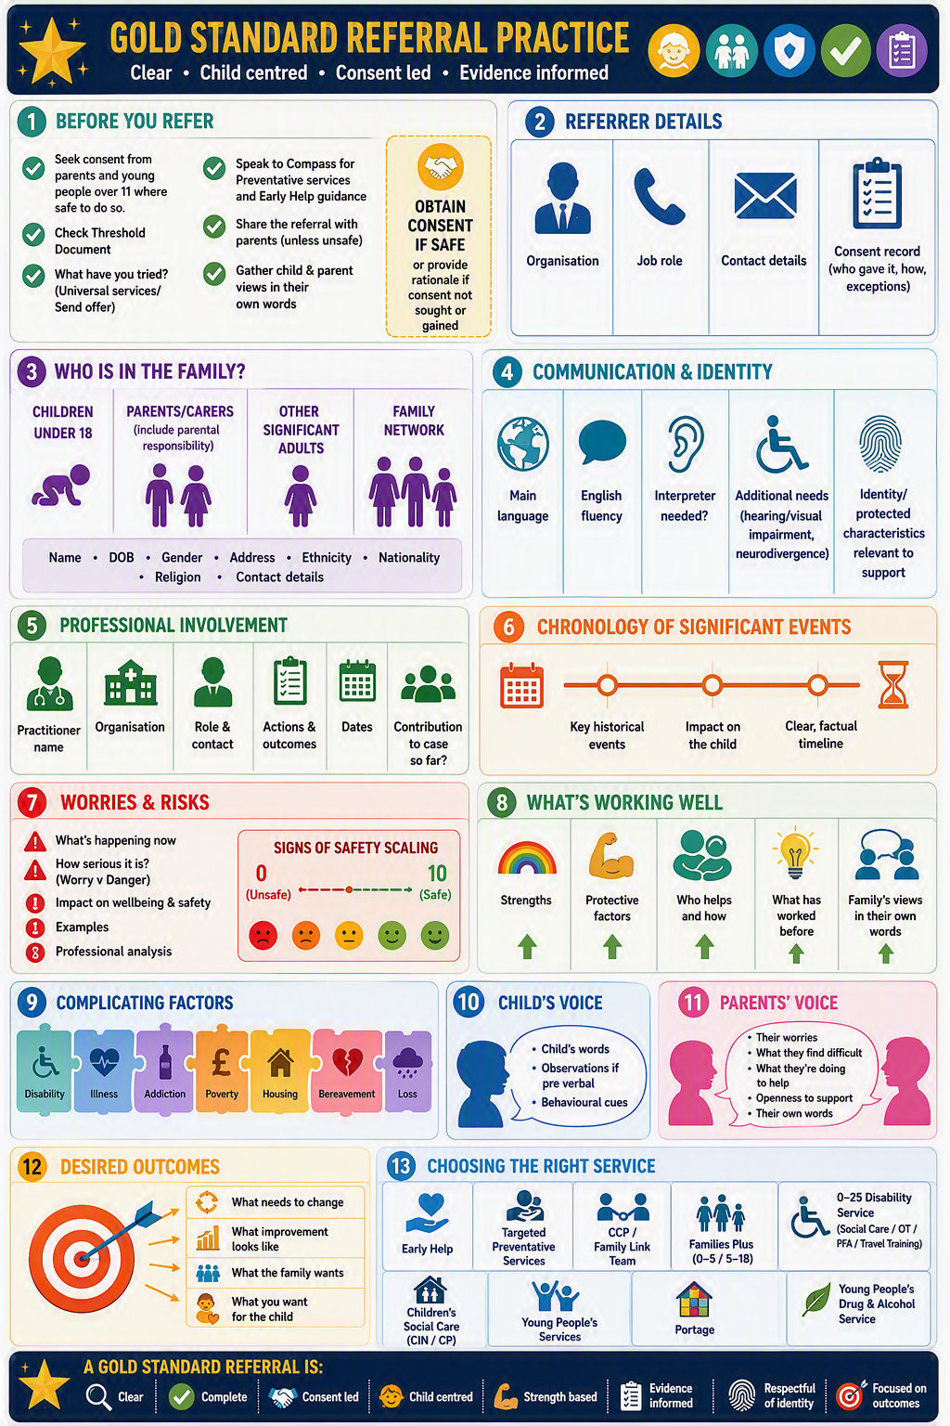


Acronyms & Initialisations?
ART (MASH) | Access & Response Team / Multi-Agency Safeguarding Hub
FAM+ | Families Plus (0-5yrs) & (5-18yrs)
YPS | Young Person Support
YJS (YOT) | Youth Justice Service (formerly Youth Offending Team)
EHAP | Early Help Assessment & Plan – (Compass Team)
LADO | Local Authority Designated Officer
FGM | Female Genital Mutilation
CSE/CCE  (MARMM) (PIMM) (CP-ROTH) | Child Sexual Exploitation/Child Criminal Exploitation (Multi-Agency Risk Management Meetings) (Partnership Intelligence Management Meetings) (Child Protection-Risks Outside the Home)
LAC | Looked After Child (Prefer Child Looked After ??? – Professional Language Matters…)
ACE’s | Adverse Childhood Experiences
CiN | Child in Need (Section 17 Children Act 1989 - Complex Needs)
CP | Child Protection (Section 47 Children Act 1989 – Significant Harm)
SGCP | South Gloucestershire Children’s Partnership
KCSiE | Keeping Children Safe in Education (Schools Colleges Statutory Guidance)
EYFS | Early Years Foundation Stage (Statutory Guidance – 0-5 care providers)
WTSC | Working Together to Safeguard Children (Multi-Agency Statutory Guidance)
DVA (MARAC) | Domestic Violence/Abuse (Multi-Agency Risk Assessment Conference)
MAPPA | Multi-Agency Public Protection Arrangements
VoC | Voice of Child (and family!)
CSPR | Child Safeguarding Practice Review
PC | Professional Curiosity (Also…. Confidence-Courage-Challenge)
Reflection – Ask yourself….
- What Acronyms and jargon do I/we use that might need explanation?
- What professional language do I/we use that I may need to rethink or challenge if seen in reports/heard used by others?
Notes

